GE8292-ENGINEERING MECHANICS
UNIT-II EQUILIBRIUM OF RIGID BODIES
10MARKS
- A system of parallel forces is acting on rigid bar as shown in fig. reduce the system to (i) a single force (ii) a single force and a couple at A (iii) a single force and a couple at B.
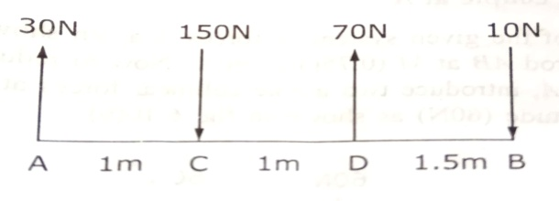
- Two vertical forces and a couple of magnitude 20KNm, acting on a horizontal rod, which is fixed at A. as shown in fig. (i) Determine the resultant of the system (ii) reduce to force couple system at A.
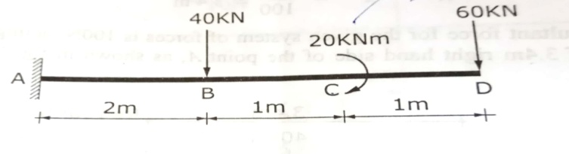
- Reduce the given system of forces acting on the beam AB in fig. (i) An equivalent force couple system at A (ii) an equivalent force couple system at B.

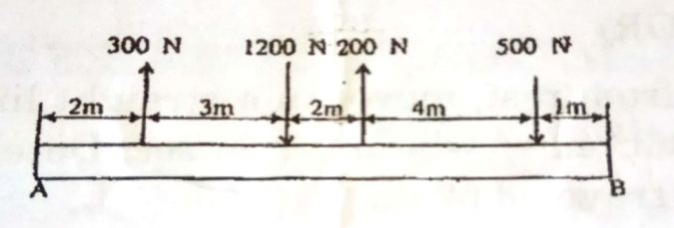

- Find the pin reaction of A and roller reaction at B. for the beam shown in fig.

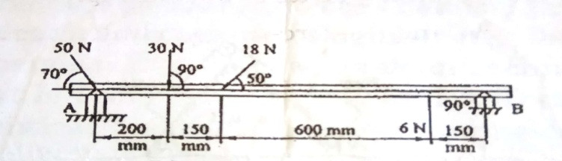

- Find the support reactions of a beam, shown in fig.
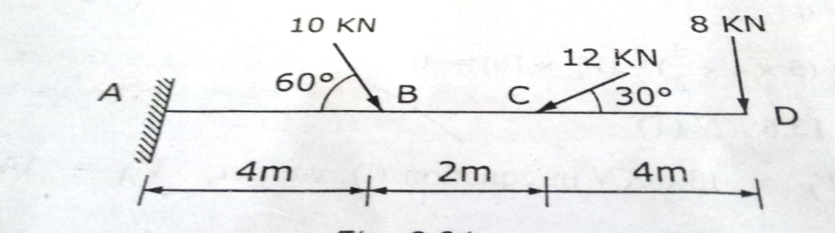

- Determine the support reactions of the beam shown in fig.

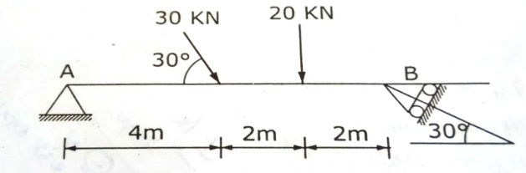

- Find the reactions at the supports A and B of the beam shown in fig.

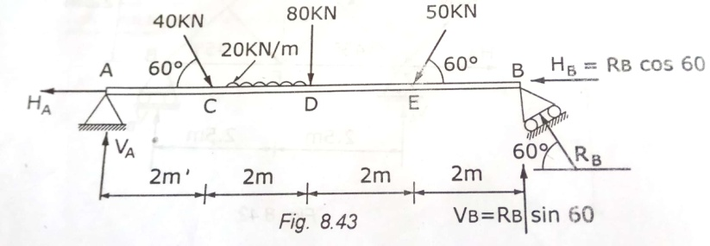

- Calculate the reactions R₁, R₂ and R₃ for the two beams AB and CD supported as shown in fig. there being a hinge connecting B and C.
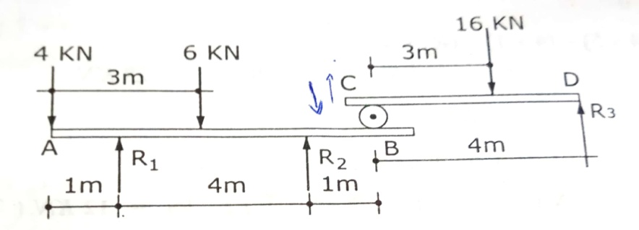

- Determine the support reactions of simply supported beam, subjected to the loads as shown in fig.
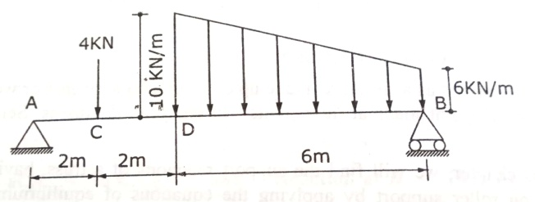

- A simply supported overhanging beam 20m long carries a system of loads and a couple as shown in fig. determine the reactions at supports A and B.
