:
GE 8292- ENGINEERING MECHANICS
UNIT-I: BASICS AND STATICS OF PARTICLES
10 MARKS
- A string ABCD, attached to two fixed points A and D has two equal weights of 1000N attached to it at B and C. the weights rest with the portions AB and CD inclined at angles of 30⁰ and 60⁰ respectively, to the vertical as shown fig. find the tensions in the portions AB, BC, CD of the string, if the inclination of the portion BC with the vertical is 120⁰.

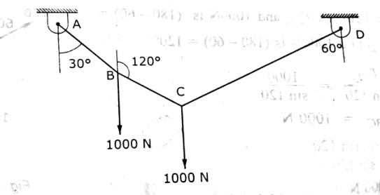
- Two identical rollers, each of weight 50N, are supported by an inclined plane and a vertical wall as shown in fig. find the reactions at the points of supports A, B and C. assume all the surfaces to be smooth.

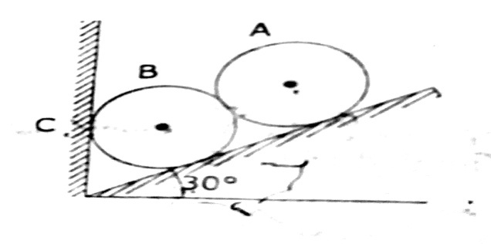
- Three smooth pipes each weighing 20KN and of diameter 60cm are to be placed in a rectangular channel with horizontal base as shown in fig. calculate the reactions at the points of contact between the pipes and between the channel and the pipes. Take width of channel as 160cm.
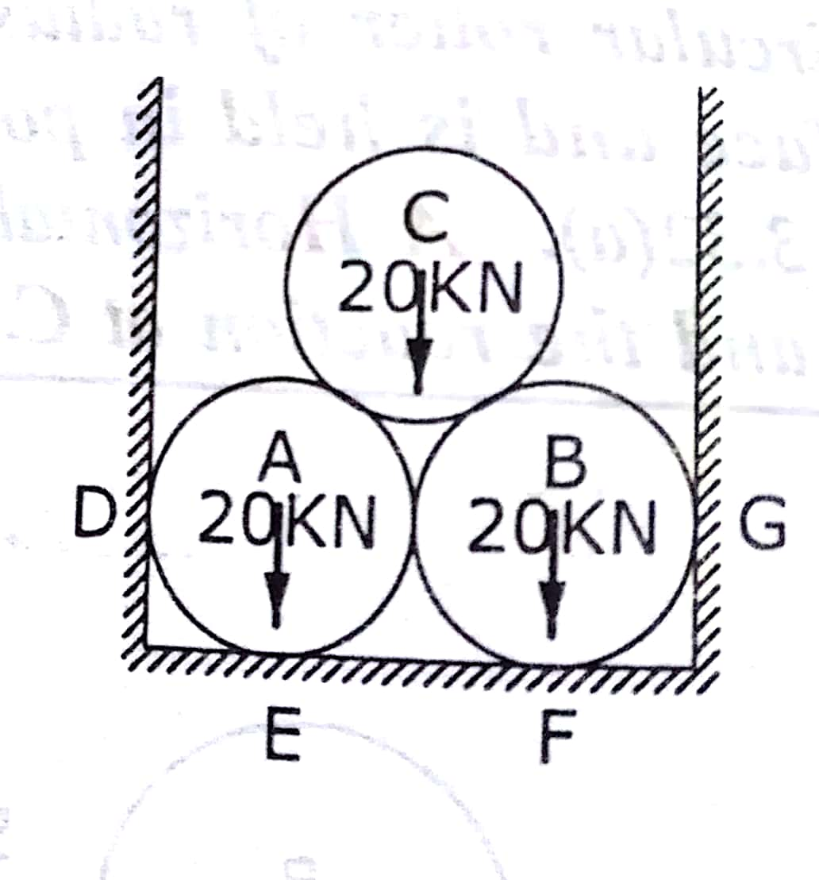

- Two rollers, each of weight 50N and of radius 10cm rest in a horizontal channel of width 36cm as shown in fig. find the reaction on the point of contacts A, B and C.
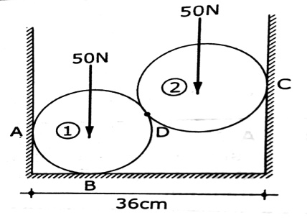

- A fine light string ABCDE whose extremity A is fixed, has weights W₁ and W₂ attached to it at B and C passes round a smooth peg at D carrying a weight of weight of 40N, at the free end E as shown in fig. if in the position of equilibrium , BC horizontal and AB, CD make angles of 150⁰ and 120⁰ respectively with BC, find
- The tension in the portions AB, BC, and CD and DE of the string.
- The values of the weights W₁ and W₂

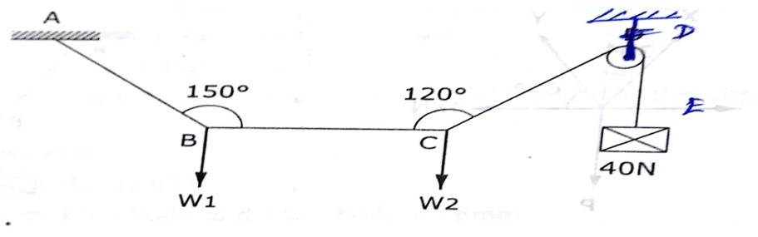

- Two spherical shells rest between two vertical faces as shown in fig. the radius of the smaller shell is 10cm and its weight is 36N, the radius of the larger is 15cm and weight is 120N. the distance between the two faces is 45cm. assuming that the reactions at the points A,B,C and D are normal to the surfaces find the magnitude of the reactions at A,B,C and D.
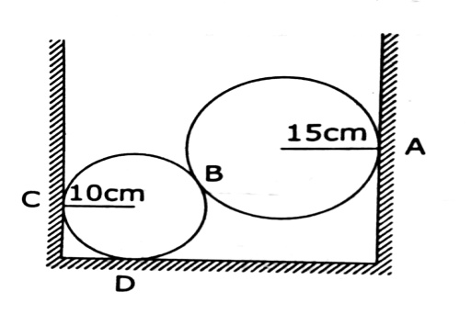
- Three links PQ, QR and RS connected as shown in fig. support loads W and 50N. find the weight W and the force in each link if the system remains in equilibrium.
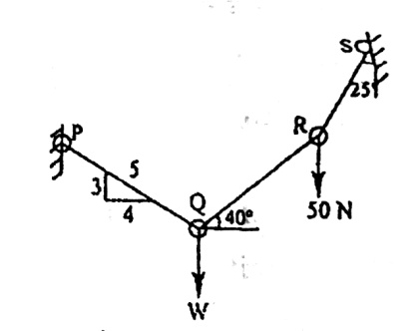
- Two identical rollers each of weight 2.5KN rest in between an inclined wall and a vertical wall as shown in fig. determine the reactions at the points of contact P, Q and R. assume the wall surfaces to be smooth.
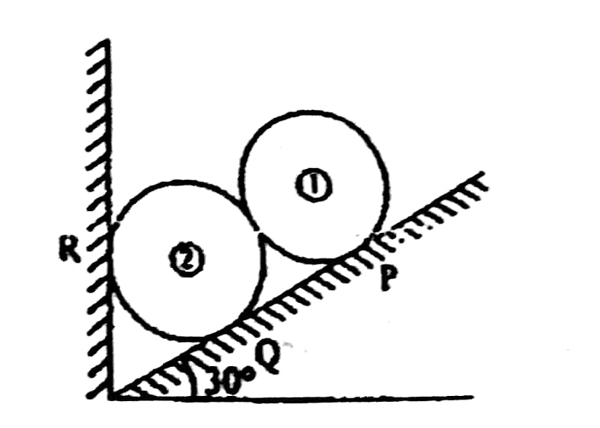

- Two cylinders C,F of diameter 60mm and 30mm. weighing 160N and 40N respectively are placed as shown in fig. assuming all the contact to be smooth, find the reactions at A,B and C.
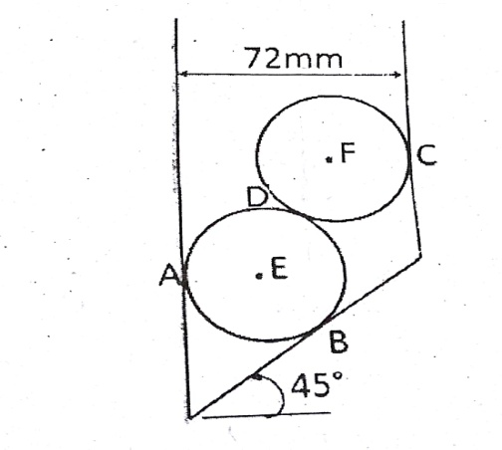
- An electric light fixture weighing 150N hangs from a point C, by two strings AC and BC as shown in fig. determine the forces in the strings AC and BC.
