The following activities are the quality establishment in our institution to expose our institution to the various advertisement platforms represented by its symbol

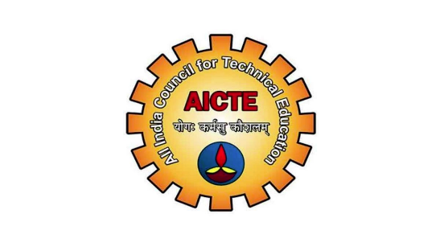 | Approved By AICTE, New Delhi
 | PermanentlyAffiliated by Anna University Chennai
 | Recoganized by UGC under the categories of 2(f)
 | Certified by ISO 9001:2015
 | Registerd by NPTEL local Chapter
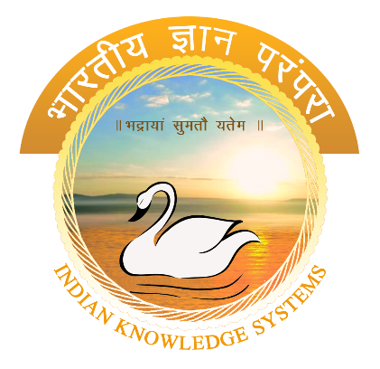 | Registered by Indian Knowledge System
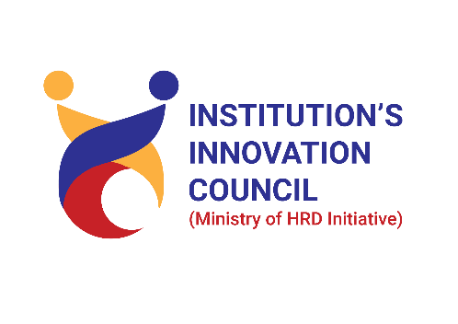 | Registered by Institutional Innovation Council
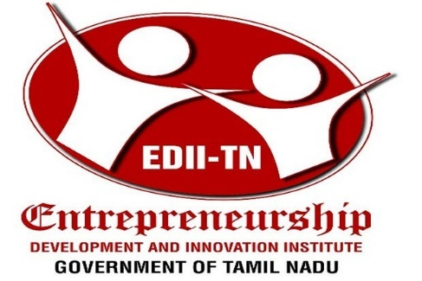 | Tamil Nadu Entrepreneurship Development & Innovation Institute Registration
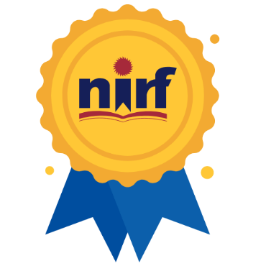 | Participate In NIRF Ranking

