SEMBODAI RUKMANI VARATHARAJAN ENGINEERING COLLEGE,SEMBODAI.
DEPARTMENT OF SCIENCE AND HUMANITIES
MODEL EXAM
SUB: GE 8292 & ENGINEERING MECHANICS DATE:16/04/2019
BRANCH: MECHANICAL MARKS: 100
ANSWER ALL THE QUESTIONS YEAR: I/II
PART- A 10X2=20
- State the principle of transmissibility.
- What is the lami’s theorem?
- State and prove varignon’s theorem.
- What are the types of supports?
- State the parallel axis theorem as applied to area moment of inertia.
- Define second moment of area.
- State D’Alembert’s principle.
- Define work-energy principle
- What is meant by coefficient of friction?
- Define rolling resistance.

PART-B 5X13=65
11.A) A string ABCD, attached to two fixed points A and D has two equal weights of 1000N attached to it at B and C. the weights rest with the portions AB and CD inclined at angles of 30⁰ and 60⁰ respectively, to the vertical as shown fig. find the tensions in the portions AB, BC, CD of the string, if the inclination of the portion BC with the vertical is 120⁰.

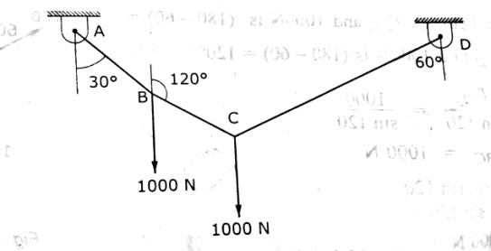
(OR)
B) Two identical rollers, each of weight 50N, are supported by an inclined plane and a vertical wall as shown in fig. find the reactions at the points of supports A, B and C. assume all the surfaces to be smooth.

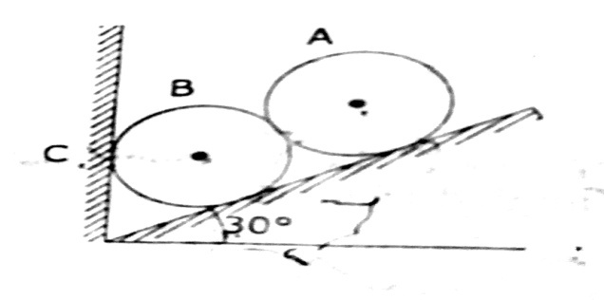
12) A). Determine the reactions of the beam shown in fig.

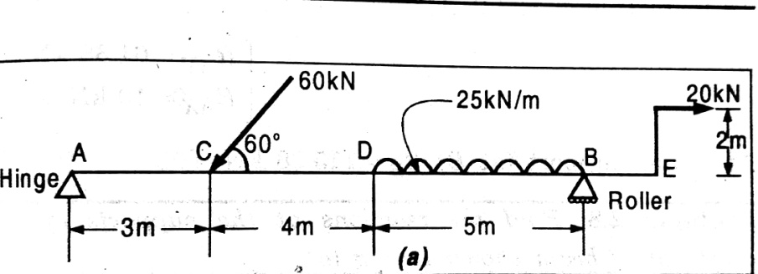

(OR)

B) Four tugboats are used to bring an ocean large ship to its pier. Each tugboat exerts a 22.5KN force in the direction as shown in the fig. (i) determine the equivalent force-couple system at O.
(i) determine the equivalent force-couple system at O.
(ii) Determine a single equivalent force and its location along the longitudinal axis of the ship.
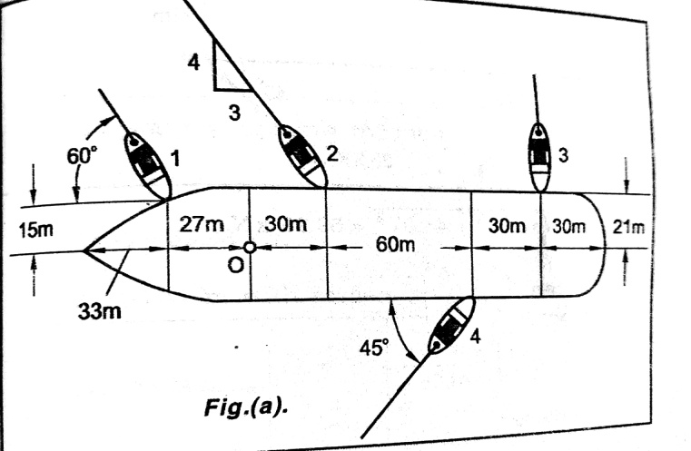
13) A) calculate the M.I. of the section about XX and YY shown in fig. all the dimensions are in cm.
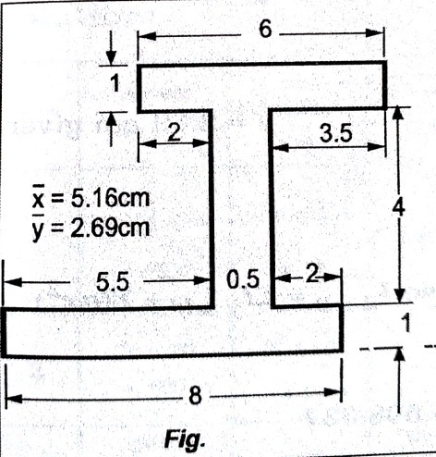
(OR)
B) For the section shown in fig. the moments of inertia with respect to x and y axes have been computed and given as I_{X}=405.5cm⁴; I_{Y}=272.3cm⁴ determine (i) the principal axes of the section about O,
(ii) The values of the principal moment of inertia the section about O.
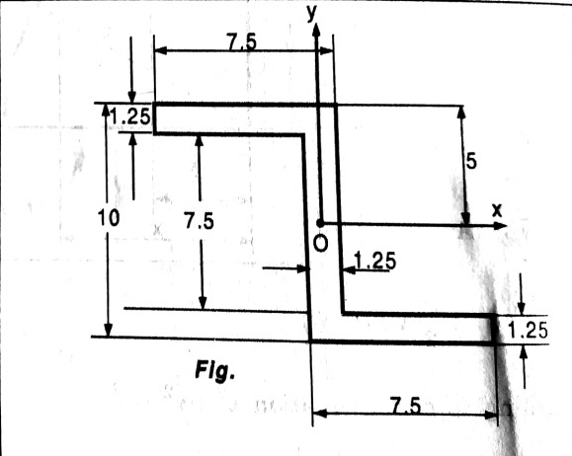

14) A) A body moves along a straight line so that its displacement from a fixed point on the line is given by s=4t³-6t²+20. Find the displacement, velocity and acceleration at the end of 3seconds.
(OR)
B) Two rough planes inclined at 30⁰ and 60⁰ to horizontal are placed back as shown in fig. two blocks of weight 50N and 100N are placed on the planes and are connected by cord passing over a frictionless pulley. If the coefficient of friction between the planes and block is 0.33, find the resulting acceleration of the blocks and the tension in the cord.
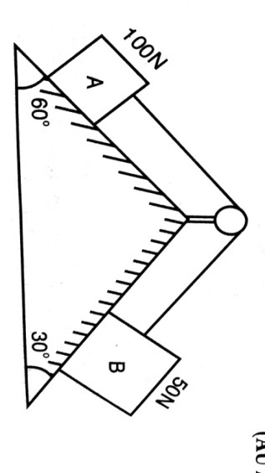
15) A) Determine the value of P for the system shown in fig. to cause the motion to impend? The coefficient of friction between the contact surfaces to be 0.25. Assume the pulley is smooth.

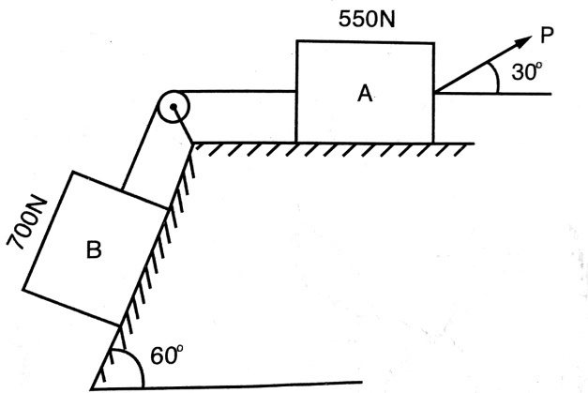
(OR)
B) What should be the value of the angle Ө so that motion of the 1000N block impends down the plane? The coefficient of friction µ for all surfaces is 1/4. The coefficient of friction µ for all surfaces is 1/4. 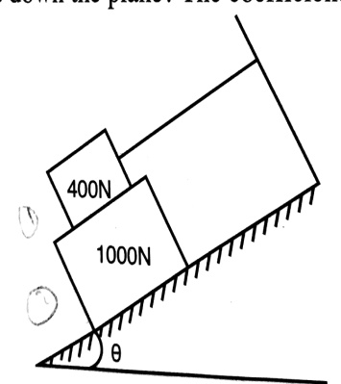

PART-C 1X15=15

16. A) The equation of motion of a particle is given, acceleration (a) in terms of time (t) as below. a=3t²+2t+4, in which acceleration is in m/s² and time‘t’ is in seconds. It is observed that the velocity
Of the particle is 12m/s after 4seconds; and the displacement of the particle is 8m after 4seconds. Determine (i) velocity after 8seconds
(ii) Displacement after 2seconds
(OR)
B) Block (2) rests on block (1) and is attached by a horizontal rope AB to the wall as shown in fig. what the force P is necessary to cause motion of block (1) to impend? The coefficient of friction between the blocks is 1/4 and between the floor and block (1) is 1/3. Mass of blocks (1) and (2) are 14kg and 9kg respectively.
