SINCET / DEPT. OF MECH. / DAILY TEST-2 / EM

- A string ABCD, attached to two fixed points A and D has two equal weights of 1000N attached to it at B and C. the weights rest with the portions AB and CD inclined at angles of 30⁰ and 60⁰ respectively, to the vertical as shown fig. find the tensions in the portions AB, BC, CD of the string, if the inclination of the portion BC with the vertical is 120⁰.

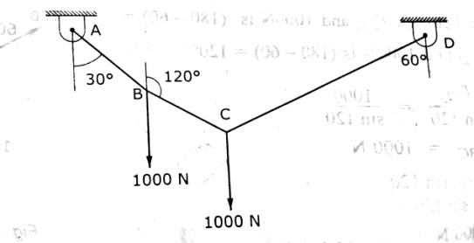
- A fine light string ABCDE whose extremity A is fixed, has weights W₁ and W₂ attached to it at B and C passes round a smooth peg at D carrying a weight of weight of 40N, at the free end E as shown in fig. if in the position of equilibrium , BC horizontal and AB, CD make angles of 150⁰ and 120⁰ respectively with BC, find
- The tension in the portions AB, BC, and CD and DE of the string.
- The values of the weights W₁ and W₂

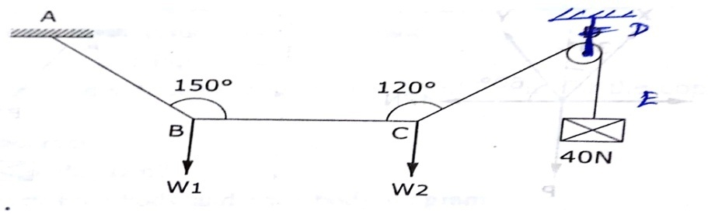

- An electric light fixture weighing 150N hangs from a point C, by two strings AC and BC as shown in fig. determine the forces in the strings AC and BC.
